**Greenfield Medical Centre**

**Patient Information Leaflet**

[Greenfield Medical Centre is a partnership providing NHS Services under an NHS England General ] Medical Services Contract.

143 -145 Cricklewood Lane

Telephone No.0208450 5454

Email address:greenfieldmc@nhs.net]

Website: www.greenfieldmc.co.uk

**GP services are provided   
to the following areas:**

**Opening hours**

|  |  |  |
| --- | --- | --- |
| Mon–Friday | 8:00 am | 6:30 pm |
| Saturday | **closed** | **closed** |
| Sunday | closed | closed |

**Improved access/Extended hours**

**We offer some out of hours appointments please ask for details.**

**Our local GP federation also offers appointments out of hours and at weekends please ask or details.**

**Services we provide**

**alo**ng with routine appointments, the practice offers the following services:

* **Family planning –** Our practice nurse will be able to offer you family planning advice.
* **Immunisations –** The nursing team administers vaccines for both adult and child immunisations. We offer appointments to suit the patient subject to availability.
* **Minor surgery –** Your GP will advise on minor surgery that is offered.
* **Cervical smear testing –** For women aged 25 – 65. These tests are undertaken by the nursing team.
* **Chronic disease management –** We hold a range of clinics to help our patients to manage their long-term medical problems including asthma, diabetes, hypertension, kidney disease and heart disease.
* **Other services –** Health checks for adult patients aged 16 to 74 years and 75 years and over are also available especially for those who have not seen a clinician at this practice. Details are available from reception and on the practice website.

We also offer the following clinics and checks: antenatal, baby, post-natal, smoking cessation. We can refer locally for counselling on drug and alcohol addiction.

From time to time, other services may be available such as raising awareness of a particular disease or condition. We will advertise this information on our website and within the practice.

**Teaching practice** The practice is a teaching practice and occasionally trainee GPs or Foundation Doctors may, as part of their training, be required to sit in with their trainer GP or other health professionals during the initial stages of their training.

You will always be asked if you consent to this prior to your consultation. If you do not consent, the trainees will not sit in on your consultation.

After an initial period all the trainees (who are qualified doctors) will see patients on their own. All of these doctors are supervised by their trainers during their time at the practice.

------------------------------

**How to register at the practice**

The quickest way to register at the practice is to use the practice website. You must live within the practice area which is shown on the website. If you are unable to use the website, please contact the practice for information about how to register.

**Patients’ rights and responsibilities**

When registering, you have a right to express a preference to be seen by a particular GP. This will be recorded on our clinical system and, where possible, you will be allocated appointments with that clinician. All patients will be assigned an accountable GP.

You will also be offered a health check when you join the practice for the first time (see the practice website for a full list of your rights and responsibilities).

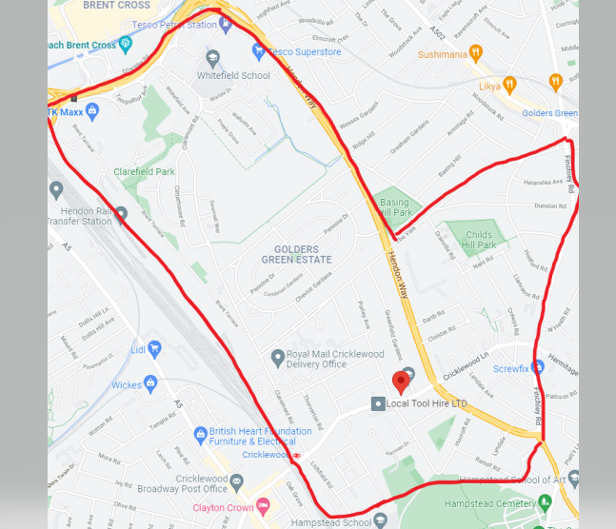

**Further information can be sought from** [**www.nhs.uk**](http://www.nhs.uk)

**Comments, suggestions and complaints**

If you would like more information about any of the services we provide, please ask a member of staff, telephone or log into the practice website. Details are shown on the front of this leaflet.

Our aim is to give the highest possible standard of service. We would like you to tell us what you think about the service we

**Home visits**

Home visits are at the discretion of the GPs and are usually for those patients who are housebound or have significant health issues. Should you require a home visit, please contact reception]. A clinician will then telephone you to discuss your request.

Home visits are usually carried out between 12.30 & 2pm Monday to Friday.

**When we are closed**

When the practice is closed, if you urgently need medical help or advice and it is life threatening, dial 999. If it is not life-threatening, contact NHS 111 by calling 111 or accessing via [www.nhs.uk](http://www.nhs.uk)

**Appointments and accessing practice services**

To make an appointment to see your GP or any member of our healthcare staff or to access any other of our practice services, please contact the surgery by telephone 0208 450 5454 or visit the practice website and access the “Patchs” on line [consultation tool.

The practice website contains all the relevant practice information that you are likely to require. It is the quickest way to access the services you may need.

**Threats of violence or abuse of our staff**

Our staff work hard to provide you with the best possible service. Please treat them with the courtesy and respect they deserve. We operate a zero-tolerance policy and may refuse to provide services to individuals or those accompanying individuals who are violent, threaten violence, commit or threaten to commit a criminal offence

**Patient** **Participation Group**

We have an active Patient Participation Group (PPG), ensuring that our patients are involved in decisions about the services provided by the practice.

Further information about our PPG is available online at [www.greenfieldmc.co.uk](http://www.greenfieldmc.co.uk)

**Patient data**

All clinical and administrative staff have an ethical as well as a legal duty to protect patient information from unauthorised disclosure and in accordance with UK GDPR.

The patient privacy notice is available on the practice website.

**The practice team**

**Partners :- Dr Antonia Briffa – MBBS DRCOG MRCGP**

**Dr Hilary Dunseath- MBBS MRCGP**

**Jacqui Tonge Managing Partner (non clinical)**

**Salaried GPs**

**Dr Emma Shall – MA MBBS MRCGP DRCOG**

**Dr Miriam Kahan – MBBS BSC MRCGP**

**DR Saloni Kapoor – BSC (Hons) MBBS MRCGP DIPlBLM BSLM**

**Nursing Staff**

**Yvonne Kirya – Nursing Associate**

**Practice Nurse – Vacant**

**Practice Pharmacist**

**Sabbir Ahmed**

**Practice Paramedic**

**Vacant**

**Other Healthcare Professionals**

**The practice has access to FCP/ Health & Wellbeing Coach/ Social Prescribers/Dietician through our membership of South West Barnet Primary Care Network.**

**The network is a group of 8 local practices that work together to support the health needs of our local population.**

**Please see details of our reception and administrative staff on our website.**

**NHS England Contact**

Greenfield Medical Centre provides NHS services on behalf of NHS England, PO Box 16738, Redditch, B97 9PT.

Telephone: 0300 311 2233

Email: [england.contactus@nhs.net](mailto:england.contactus@nhs.net)

This leaflet was produced from the Patient Information Leaflet Policy dated 02.12.2021

**Prescriptions/repeat prescriptions**

Your GP will initiate any prescription that they determine you require. Repeat prescriptions can be ordered in the following ways:

* In person – By ticking the required medications on your prescription and placing it in the dedicated box, located main reception area
* Online – Please log in and order via our website [www.greenfieldmc.co.uk](http://www.greenfieldmc.co.uk)
* By email to greenfieldmc@nhs.net
* **Please allow 48 hours for collection (excluding weekends and bank holidays) when ordering repeat prescriptions. PLEASE NOTE WE DO OT TAKE PRESCRIPTIONS OVER THE PHONE.**